9238-MANGAYARKARASI COLLEGE OF ENGINEERING

(Approved by AICTE, New Delhi & Affiliated to Anna University, Chennai)

MANGAYARKARASI NAGAR, PARAVAI, MADURAI – 625 402

Website: http://mce-madurai.ac.in E-Mail: : mangai.enggcoll@gmail.com

# 

# SMART WATER MANAGEMENT

# PHASE-5

PROJECT MENTOR

R.M.SENTHIL KUMAR

Project Members

J. GAYATHRI(923821106015)

A.BHUVANESHWARI(923821106012)

C.JAYANTHI(923821106020)

M. MAHALAKSHMI(923821106022)

S.PRIYADHARSHINI(923821106039)

SMART WATER MANAGEMENT

PHASE-5

## **INTRODUCTION:**

* Water scarcity issues are forcing the water management sector to develop smart water systems that improve efficiency and sustainability. IoT connected smart water solutions are being deployed to monitor, control and regulate the usage and quality of water.
* Equipment like sensors, smart water meters, data processing software and control systems are helping smart water management systems overcome outdated technology and increasing labour costs.

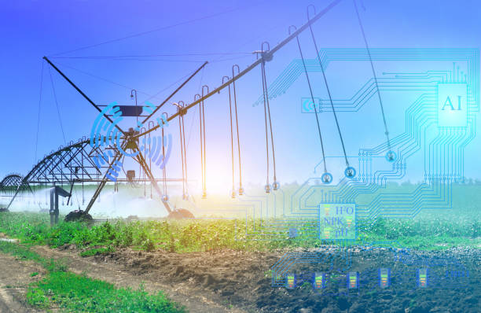

**OBJECTIVES OF SMART WATER MANAGEMENT:**

* The main objective of smart water management is sustainable and reasonable usage as well as recycling of the water resources
* Smart water management helps to minimize usage of water usually utilized in higher amounts for manufacturing, agriculture, and power production.
* Reduce wasting water.
* Improved water quality.
* Enhancing the quality of water and preventing contamination due to the wastage of chemicals and natural pollution like acidification.
* Improves the efficiency of water systems.
* Implement leakage control.
* Practice consumption monitoring.
* Implement consumption monitoring using the IOT powered water management systems.
* Smart water management using the IoT technology will help in enhancing the efficiency of the water systems like treatment plants, water collectors, waste water recycling centers, and distribution mains.
* You can attain leakage control by implementing smart water management devices that are equipped with moisture and leak sensors.
* Transparency.
* Optimized cost.
* Sustainability.

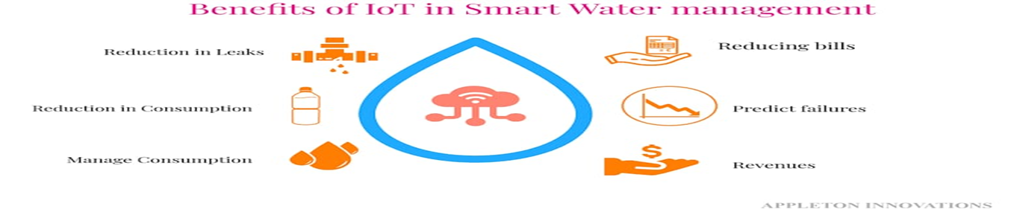

**IOT DEVICE SETUP:**

* The below diagram shows the IOT device setup blockdiagram.

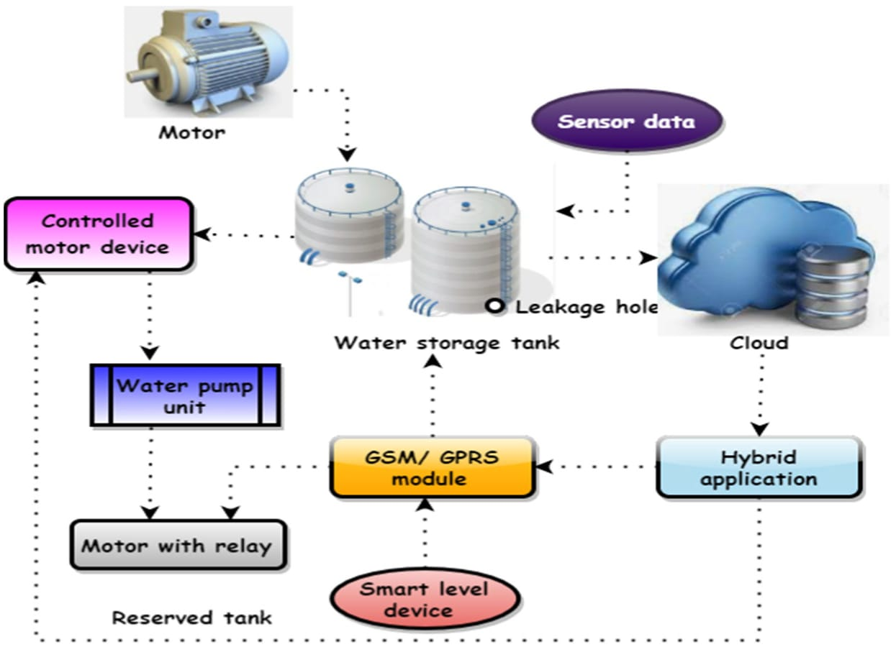

# **ESP-32 WIFI MODULES:**

* , showing ESP32 is a single 2.4 GHz Wi-Fi-and-Bluetooth combo chip designed with the TSMC low-power 40 nm technology.
* It is designed to achieve the best power and RF performance robustness, versatility and reliability in a wide variety of applications and power scenarios.

***Ranges:***

* Range of wifi module from 50 metres (160 ft) or less.

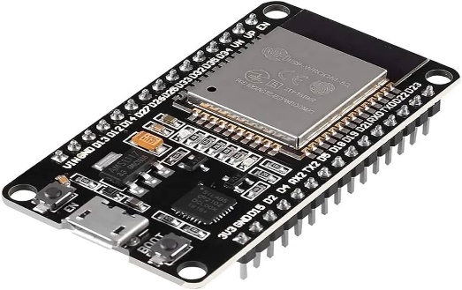

# **WATER FLOW MEASURES AND METER:**

* A flow meter is a device that measures how much liquid or gas moves through a pipeline in a given period of time.
* Turbine meters measure flow by detecting the rotations of a rotor in the flow stream.

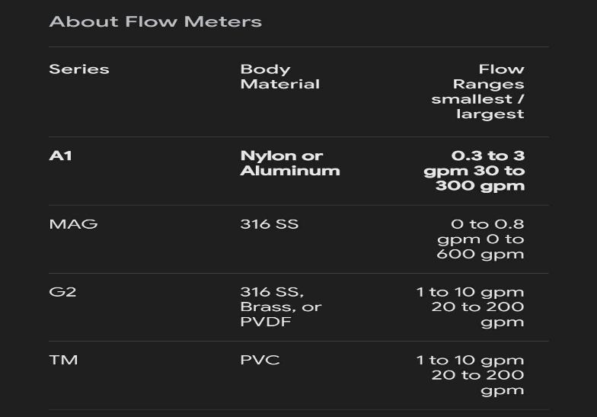

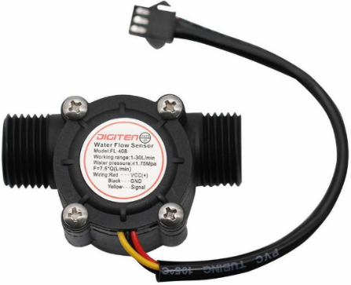

**TENSIOMETER:**

* A tensiometer in soil science is a measuring instrument used to determine the matric water potential in the vadose zone.
* This device typically consists of a glass or plastic tube with a porous ceramic cup and is filled with water.
* A measuring instrument used to measure the surface tension (γ) of liquids or surfaces.

*RANGES:*

* 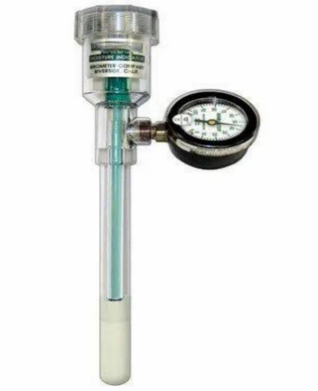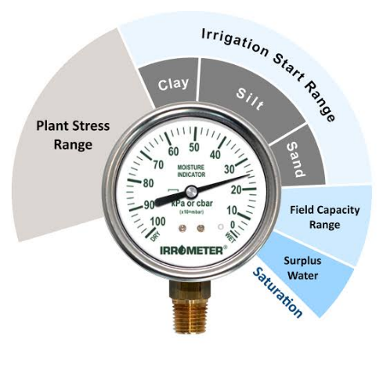Tensiometer gauges from commonly range from 0 to 100 cbar(or kba) Where 0 indicates saturation of the soil.

# **GSM MODULE:**

* A GSM module is a device that allows electronic devices to communicate with each other over the GSM network.

* GSM is a standard for digital cellular communications, which means that it provides a platform for mobile devices to communicate with each other wirelessly.

***RANGES:***

It’s operating voltage ranges from 3.4v ~ 4.4v

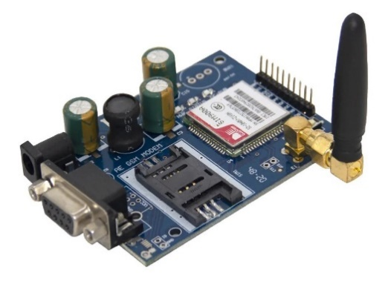

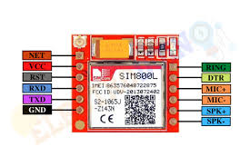

# **MICROCONTROLLER:**

* A microcontroller is a compact integrated circuit designed to govern a specific operation in an embedded system.
* A typical microcontroller includes a processor, memory and input/output (I/O) peripherals on a single chip.

***RANGES:***

* Options ranges from the simple 4-bit,8-bit or 16-bit processors to more complex 32-bit or 64-bit

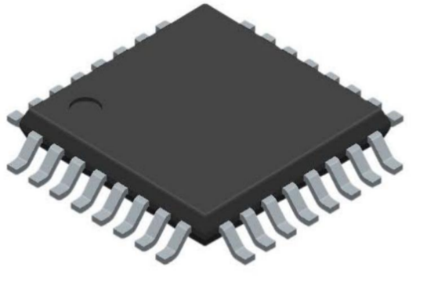

**MOTOR WITH RELAY:**

* A relay is an electrically operated switch. It consists of a set of input terminals for a single or multiple control signals, and a set of operating contact terminals.
* The switch may have any number of contacts in multiple contact forms, such as make contacts, break contacts, or combinations.

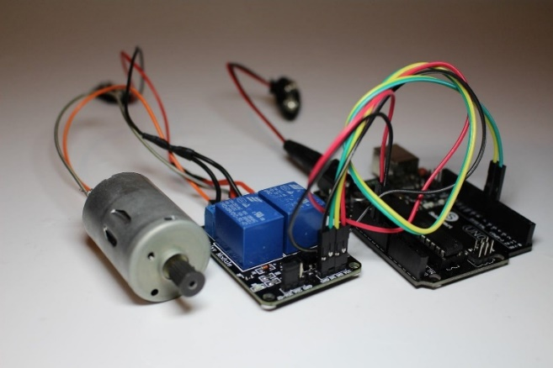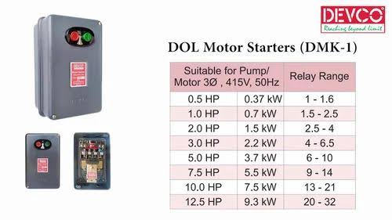

**CONNECTING WIRES:**

* connecting wire allows travels the electric current from one point to another point without resistivity.
* Resistance of connecting wire should always be near zero. Copper wires have low resistance and are therefore suitable for low resistance.

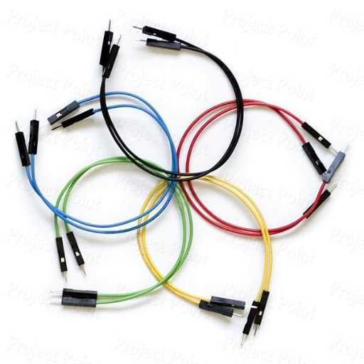

PLATFORM DEVELOPMENT:

* Smart technology can change conventional water and wastewater systems into instrumented, interconnected, and intelligent systems.
* Instrumented: the ability to detect, sense, measure, and record data.
* Interconnected: the ability to communicate and interact with system operators and managers.
* The project will develop a high-precision smart irrigation system concept for agriculture depicted.
* The main idea is to enable the optimisations of irrigation, water distribution and consumption based on a holistic analysis that collects information from all aspects.
* The system including even the natural water cycle and the cumulated knowledge related to growing particular plants.

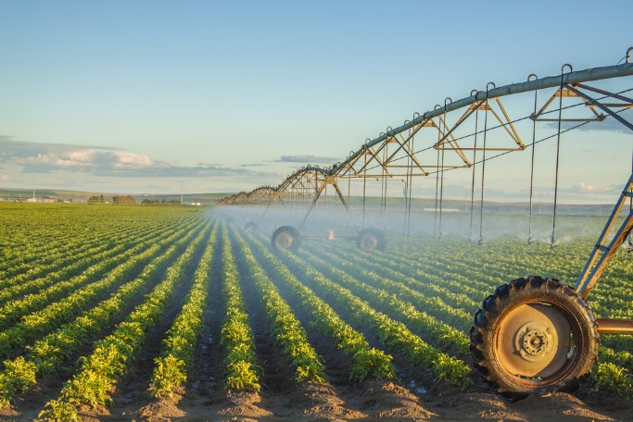

* 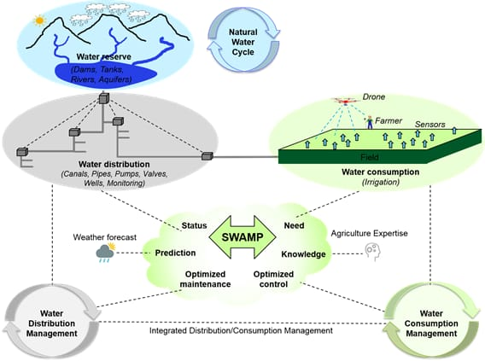The SWAMP platform will provide mechanisms for data acquisition from heterogeneous sensors, decision making using a variety of different techniques and changing system behaviour by sending commands to actuators

**CODE IMPLEMENTATION:**

import network

import time

import requests

import machine

import utime

# Wi-Fi configuration

WIFI_SSID = "Wokwi-GUEST"

WIFI_PASSWORD = ""

# ThingSpeak configuration

THINGSPEAK_API_URL = "https://api.thingspeak.com/update"

WRITE_API_KEY = "CXPFDF6X2N4ZKWUI"

# Ultrasonic sensor configuration

TRIGGER_PIN = 12 # GPIO12

ECHO_PIN = 14 # GPIO14

# Initialize trigger and echo pins

trigger = machine.Pin(TRIGGER_PIN, machine.Pin.OUT)

echo = machine.Pin(ECHO_PIN, machine.Pin.IN)

# Function to connect to Wi-Fi

def connect_to_wifi():

wifi = network.WLAN(network.STA_IF)

wifi.active(True)

if not wifi.isconnected():

print("Connecting to Wi-Fi...")

wifi.connect(WIFI_SSID, WIFI_PASSWORD)

while not wifi.isconnected():

pass

print("Wi-Fi connected")

# Function to measure distance

def measure_distance():

trigger.value(1)

utime.sleep_us(10)

trigger.value(0)

while echo.value() == 0:

pass

start_time = utime.ticks_us()

while echo.value() == 1:

pass

end_time = utime.ticks_us()

pulse_duration = utime.ticks_diff(end_time, start_time)

distance = (pulse_duration * 343) / (2 * 10000)

return distance

# Function to send data to ThingSpeak

def send_data_to_thingspeak(sensor_data):

payload = {

"api_key": WRITE_API_KEY,

"field1": sensor_data

}

try:

response = requests.post(THINGSPEAK_API_URL + "?api_key=" + WRITE_API_KEY, json=payload)

if response.status_code == 200:

print("Data sent to ThingSpeak successfully.")

else:

print("Failed to send data to ThingSpeak. Status code:", response.status_code)

except Exception as e:

print("Exception occurred:", e)

# Main function to run the code

def main():

connect_to_wifi()

while True:

distance = measure_distance()

print("Distance:", distance, "cm")

send_data_to_thingspeak(distance)

time.sleep(15) # Send data every 15 seconds (ThingSpeak allows updates every 15 seconds)

# Run the main function

if __name__ == "__main__":

main()

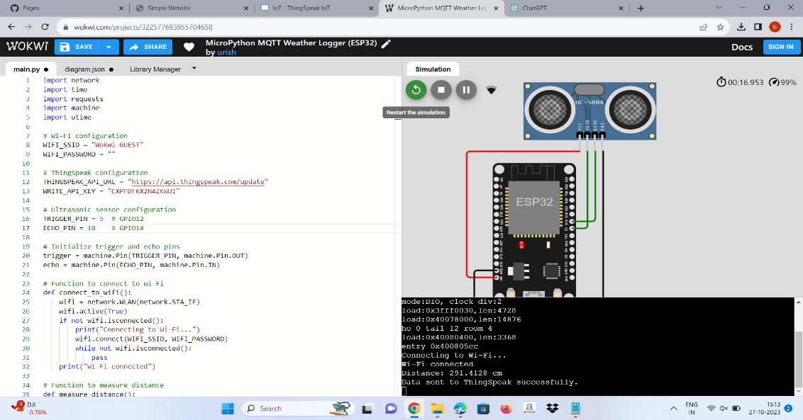

## **DIAGRAMS FOR SMART WATER MANAGEMENT:**

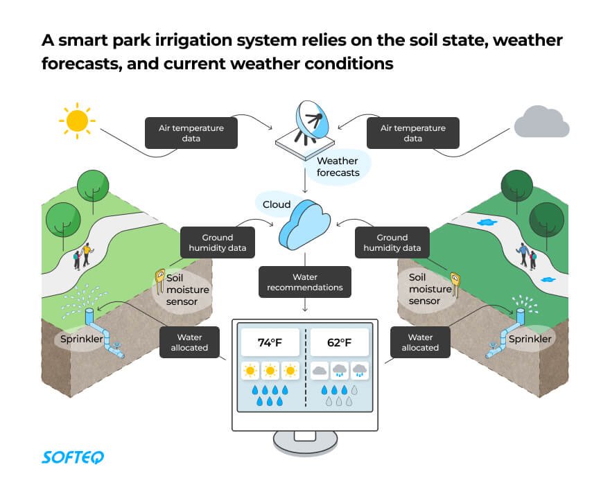

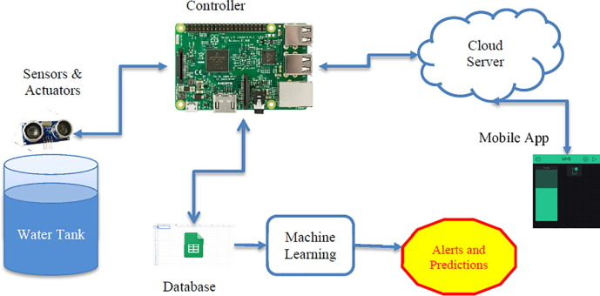

# **SCHEMATICS:**

* A “smart water management system,” which would be based on technology, is intended toenhance the efficacy and effectiveness of waterdelivery, management, and consumption as shown in Figure.
* It optimizes water supply and demand,detects leaks, cuts down on waste, and monitor sand controls water usage using sensors, data analytics, and other cutting-edge technology.
* The flow rate and pressure of water in the distribution system are measured using an electromagnetic flow meter with a data logger.
* 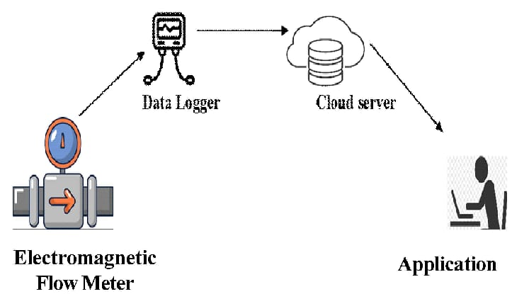It is based on the electromagnetic induction concept, which employs a magnetic field to cause a conductor to experience a voltage as it passes through the field
* Water shortage is the major issue in the modern world. Conservation is urgently needed as a result of the population's growing need for water on a minute-by-minute basis. Every aspect of life has been automated thanks to information and technology. Automation is now simpler because to the expansion of the Internet of Things (IoT)

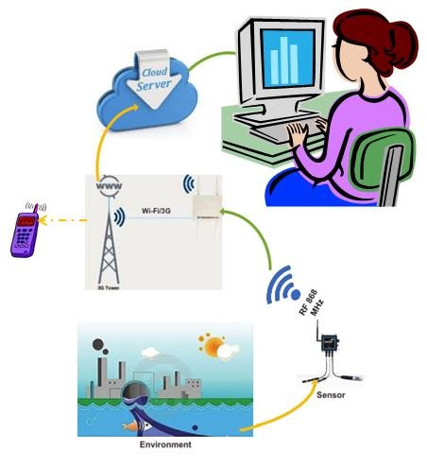

# **SCREENSHOTS:**

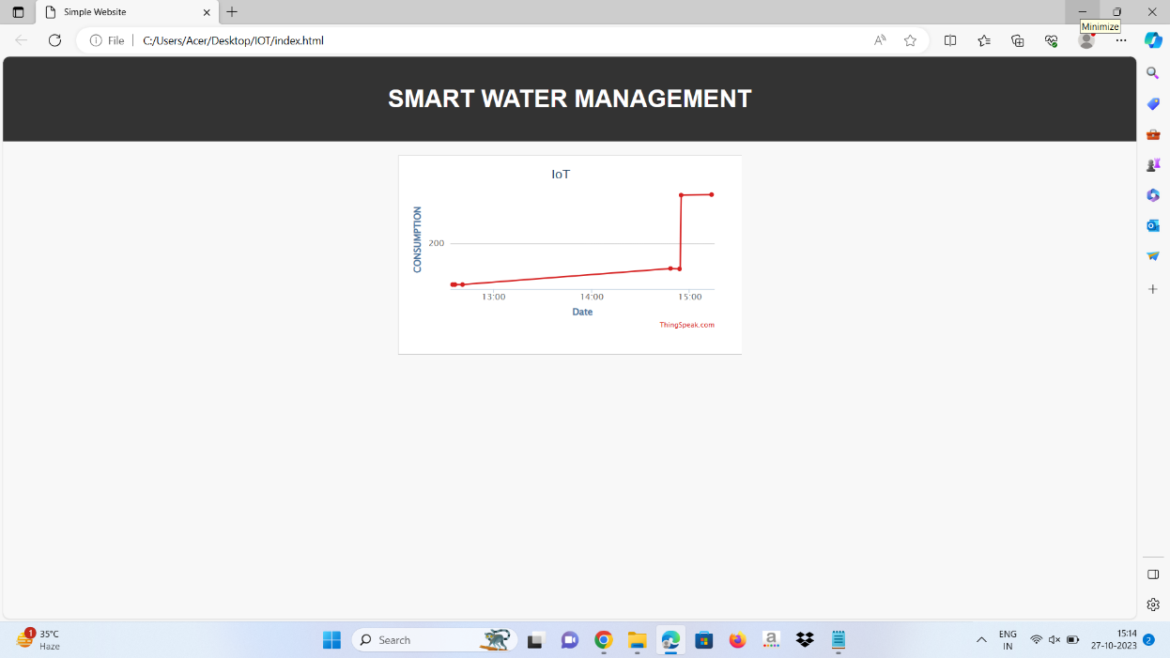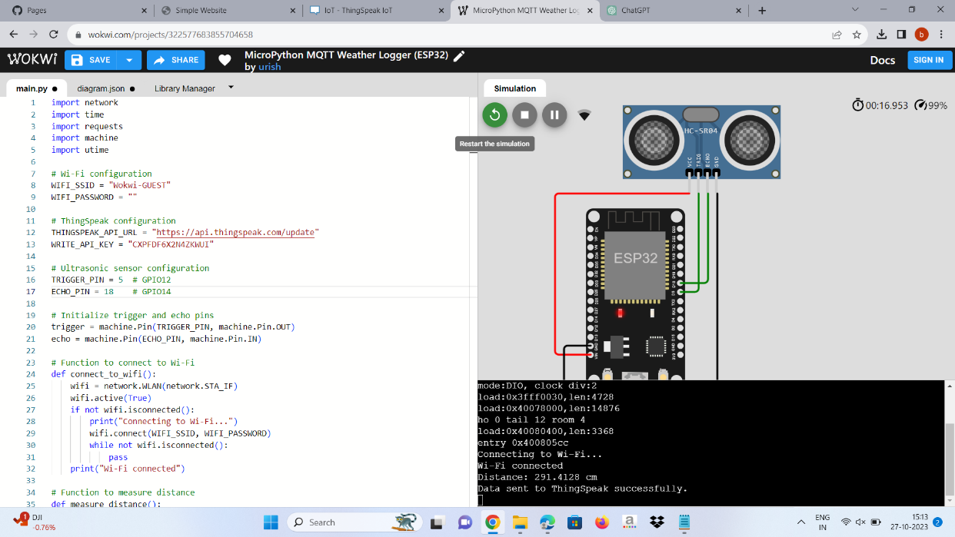

**EXPLANATION:**

* A smart city water management system can enable you to collect real-time data—information that helps you visualize water distribution across the network. Residents with smart meters can make more informed decisions as a result, leading to a more sustainable city overall.
* waste and disrupted water supply chains are a drain on the city’s budget. IoT can help you watch the health of water equipment and detect problems, like leaks in pipes. This allows operators to receive alerts and start fixing issues immediately.
* In the meantime, AI predictions allow you to nip problems in the bud by preventing failures before they cause severe incidents. With AI, city administrators can also watch the watershed and predict which areas are likely to flood, information that will help local authorities warn residents, manage traffic, and keep the city on its feet.

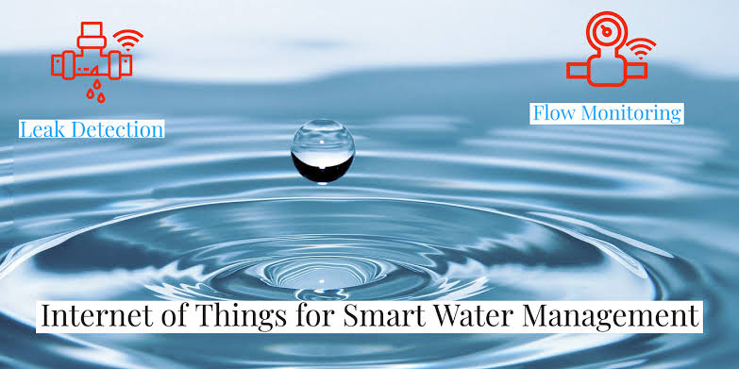

**MAIN BENEFITS:**

* Better transparency in water management
* Fewer incidents
* Enhanced control over the water supply
* Saved city budget
* Improved city sustainability
* Water Quality Management.

**REAL-TIME EXAMPLES:**

* Cartagena, a city in Columbia, has smart irrigation in its municipal parks and gardens.
* solution calculates the amount of water each area needs depending on the state of the soil, weather forecast, and irrigation calendar.
* something goes wrong, such as a leak, the authorities are alerted right away and they’re even shown the location.